INGLEON PARISH COUNCIL

NOTICE IS HEREBY GIVEN OF ONE CASUAL VACANCY IN

THE OFFICE OF PARISH COUNCILLOR FOR THE PARISH OF

INGLETON

An election to fill the vacancy will be held if a written request signed by
ten local government electors for the Parish is received at the address given below within fourteen days (excluding weekends and bank holidays) of the date at the bottom of this notice.

The Returning Officer
Council Offices
Craven District Council
1 Belle Vue Square
Broughton Road
SKIPTON
North Yorkshire
BD23 1FJ

If an election is not requested, the Parish Council will fill the vacancy by co-option.

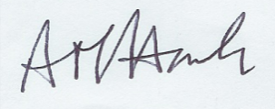
12 JANUARY 2021

CLERK OF THE PARISH COUNCIL

