DECLARATION signed by the PARISH CLERK FOR INGLETON to the effect that the status of the Accounting Statements for the year 2019/20 published on this web page are unaudited and that the Accounting Statements as published may be subject to change;

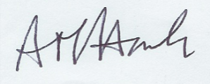

Alison M. Hack
Parish Clerk for Ingleton

30 June 2020

